Draft Solution: Mastercoil

It´s a standard SAP solution that cover the main part of the request, but not the automatic creation of the Supplier Schedule Agreement ( collective ).

Requirements:
  - Create a material (with MM01 ), Material Type: PROD (not available now in IEQ/IEP )

  - Assign all relevant materials to this group using transactions MC85 Product Group:

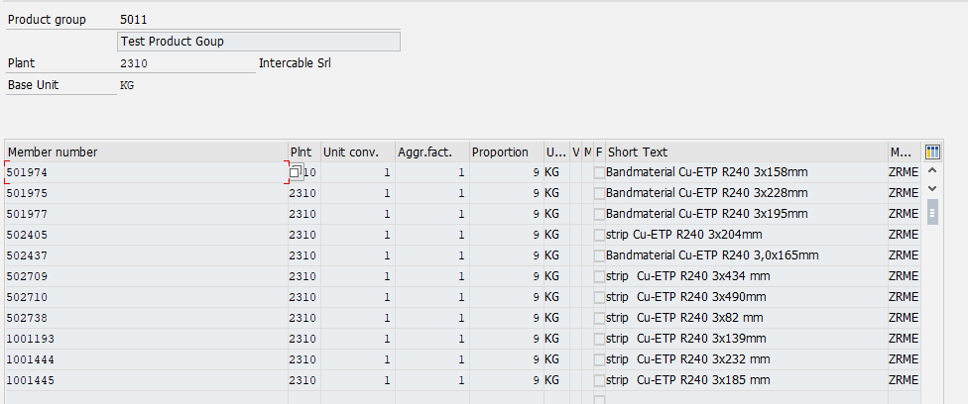

  - Go to MD04 and run it with anyone of the materials listed before, then select “Product Group” tab:

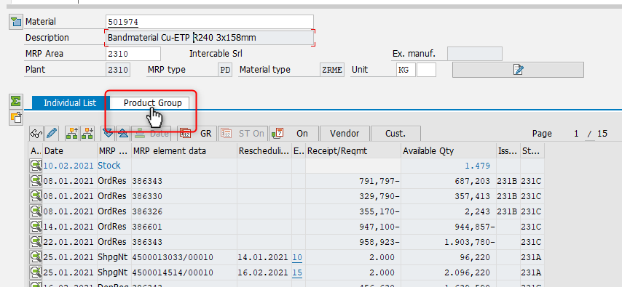

  - In this view you have all elements available in the MD04 for each single material, assigned to the Product Group, listed all together: starting from each single stock, and then all MRP element list ordered by date.

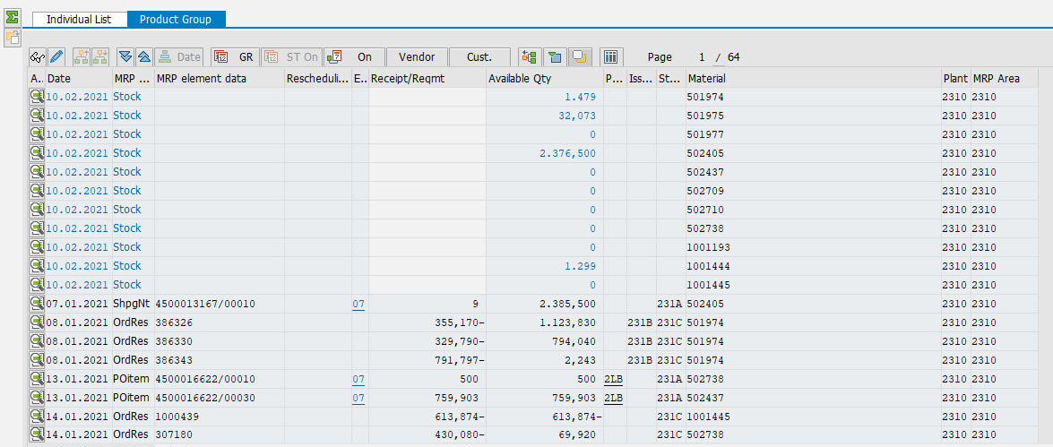

  - Moving to “Period Totals”: for example 2nd and 3rd week of 2021:

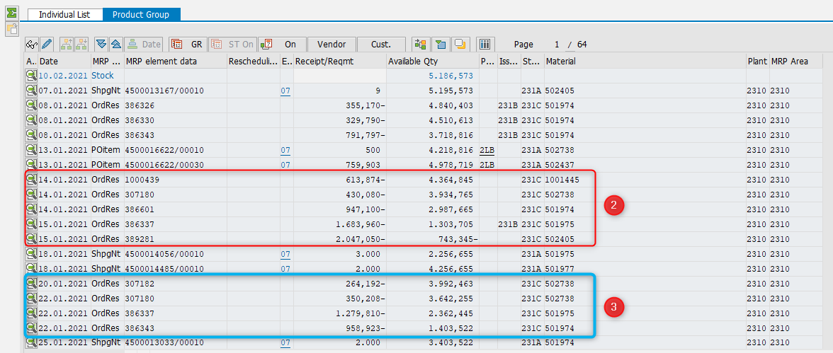

Result:

